AWS MINI PROJECT

STATIC WEBSITE HOSTING USING S3

**SYNOPSIS**

* **INTRODUCTION**
* **STATIC WEBSITE HOSITNG**
* **FEATURES**
* **HOW IT WORKS**
* **STEP BY STEP PROCESS**
* **CONCLUSION**

**DATE: 07-02-2025 PROJECT DONE BY**

**MULLAI VENDHAN S**

**INTRODUCTION:**

**An Amazon S3 bucket is a container for objects, which are files and their metadata, in Amazon's Simple Storage Service**

**STATIC WEBSITE HOSTING :**

**Static website hosting is the process of storing and delivering static websites to users. Static websites are made up of HTML, CSS, and JavaScript files that are stored on a web server. When a user requests a page, the server sends the files back to the user's browser, which displays the page.**

**Static websites are often used for simple sites like personal blogs and small business websites. They are also used for hosting reference materials like technical manuals and documentation.**

**Common examples of static websites include resume websites, portfolio websites, and other informational or read-only sites**

**KEY FEATURES:**

* **Data backup and delivery**
* **Big data analytics**
* **Disaster recovery**
* **Dynamic websites**
* **User-generated content**
* **Hosting static HTML websites**
* **Hosting dynamically complex web applications**

**HOW IT WORKS:**

* **You can create a bucket in a specific AWS Region.**
* **You can store any number of objects in a bucket.**
* **Each object has a unique identifier, or key, within the bucket.**
* **You can use S3 Versioning to keep multiple versions of an object in the same bucket.**
* **You can use bucket policies, IAM policies, S3 Access Points, and ACLs to manage access.**

**STEP BY STEP PROCESS WITH ATTACHED FILES:**

**STEP 1 >>>> CREATION OF BUCKET:**

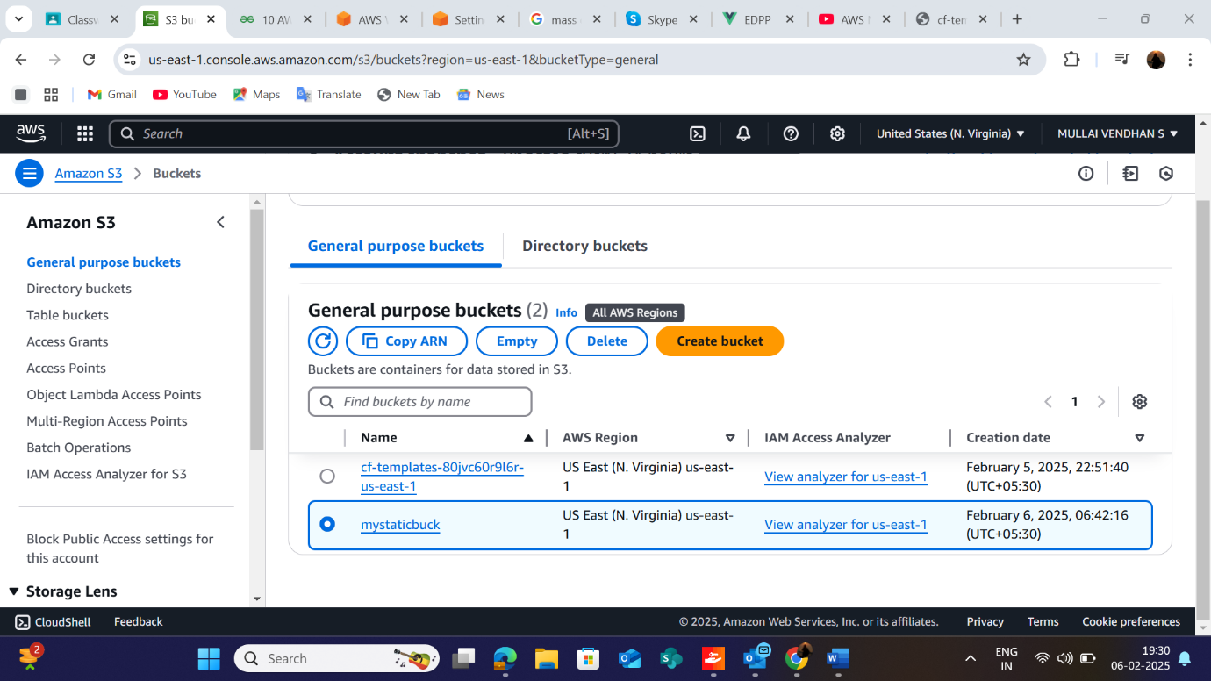

**STEP 2>>>>> CREATION OF OBJECT ---ADDING OR UPLOADING FILES:**

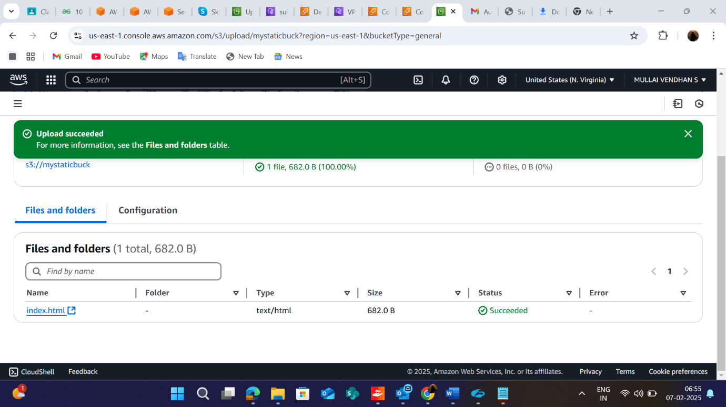

**STEP3: Making object public access as it is static website over internet, by enabling Access control list ACL and unchecking block public access**

**STEP4: STATIC WEBSITE ENABLE:**

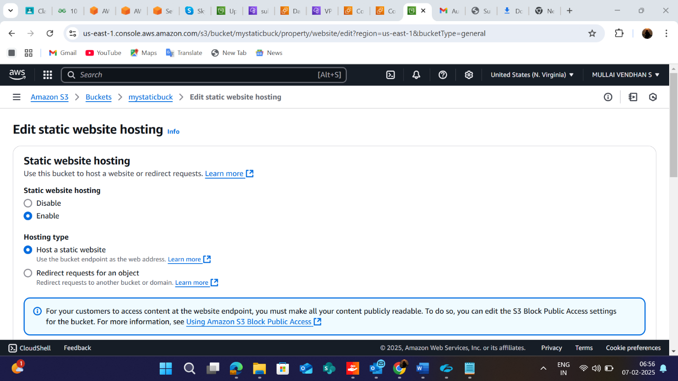

**STEP5: COPY OBJECT URL AND PASTE IT IN NEW TAB FOR THE RESULT:**

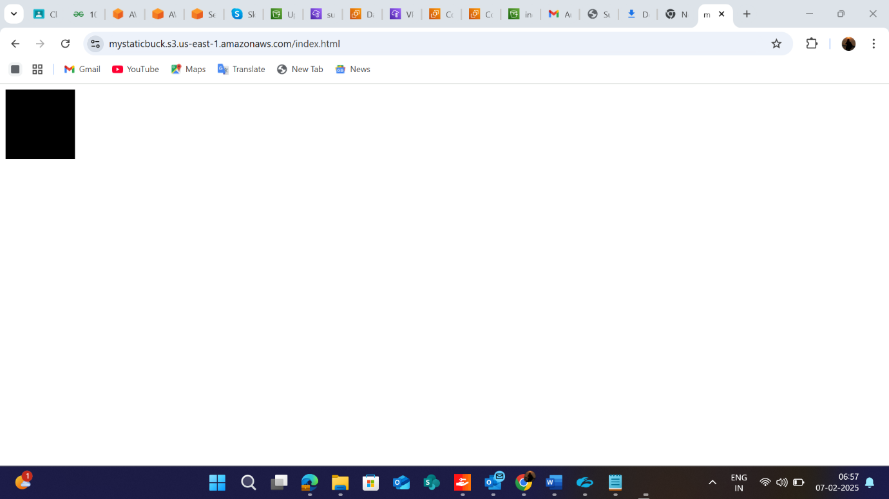

**THANK YOU**